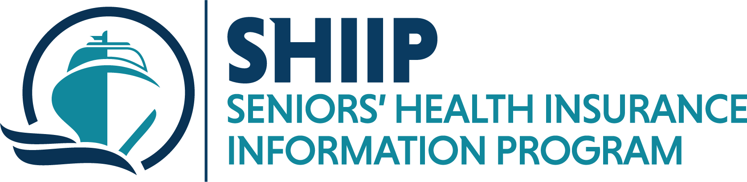
august is
N.C. Department of Insurance • Mike Causey, Commissioner
855-408-1212 (toll free) • www.ncdoi.com

National Immunization awareness month

Vaccines are an important step in protecting against serious and sometimes deadly diseases. Even healthy adults can become seriously ill and can pass certain illnesses on to others.
Immunizations are especially important for older adults and for adults with chronic conditions such as asthma, COPD, diabetes, or heart disease.
Medicare covers a number of vaccines for beneficiaries under Medicare Part B and the Medicare prescription drug plans (Part D).
Ask a SHIIP counselor for more information.
for more information contact: Laura Allen @ 704-365-1995

